

Managing Parents’ MarvellousMe Accounts within the Admin System
Please find below step-by-step instructions to:
- Check and update a parent’s MarvellousMe login (username/email address and password).
- View/report which parents at the school are yet to sign up.
- Help parents that are having trouble signing up to MarvellousMe.

How to check and update a parent’s login (username/email address and password)
- Go to Parents.
- Enter the child or parent’s name in the search bar.
- The email address the parent signed up with will be displayed.
- Select Action to update the email address and/or password.
How to view/report which parents are yet to sign up.
- Go to Parent Codes and Invites.
- Select Parents still to join in the Usage filter.
- Ignore Teacher filter.
- The results will display the names of the children that don’t yet have a parent linked to their MarvellousMe join code. You can export this information by tapping Download Selected.
NB. Teachers are also able to access this information for the pupils in their class within their Teacher account.
Help parents that are having trouble signing up to MarvellousMe.

If the parent is getting stuck on the join code/child's name screen:
- Ask the parent to check that they are entering the join code and child's name exactly as shown on the MarvellousMe invite.
  - Check that they are entering the correct characters/numbers (0/Os, 1s/Is, 5s/Ss etc are commonly confused).
  - Check that they are only entering one space between the child's forename and surname.
- Check that the child's name is correctly recorded on your MarvellousMe Admin system:
  - Go to Teachers and Pupils.
  - Type the child's name into the Search box.
  - Select Edit next to their name.
    - Check the spelling is correct.
    - Check that are no additional spaces at the beginning and end of the child’s names, and only one space between their forename and surname.
- If the child's name includes an apostrophe or if the above suggestions do not work, please contact the Support Team on support@marvellousme.com for advice.

If the parent is getting stuck on the parent details screen:
- If the parent is shown the below error message once they have entered their email address, it means that their email address has already been registered for a MarvellousMe Parent account.
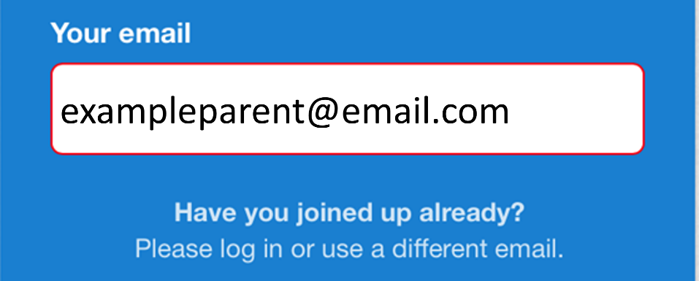
- Please ask them to return to the main screen on the Parent app/system and select Log In.
  - They can then enter their email address and password to access their Parent account.
  - If they do not know their password, they can select Forgot? to be emailed a password reset link.

