
Appraisal Process Sheet for Staff
Unlike other records, appraisals are often required to be modified over the course of the year – usually for each review period. This sheet explains that process.

Creating and Locating Appraisal Records
Exactly how your appraisals are structured will vary depending on your organisation’s setup, but you can view appraisal records and create appraisals (depending on your permissions) in the Records area. You will then be able to see a layout similar to the below:
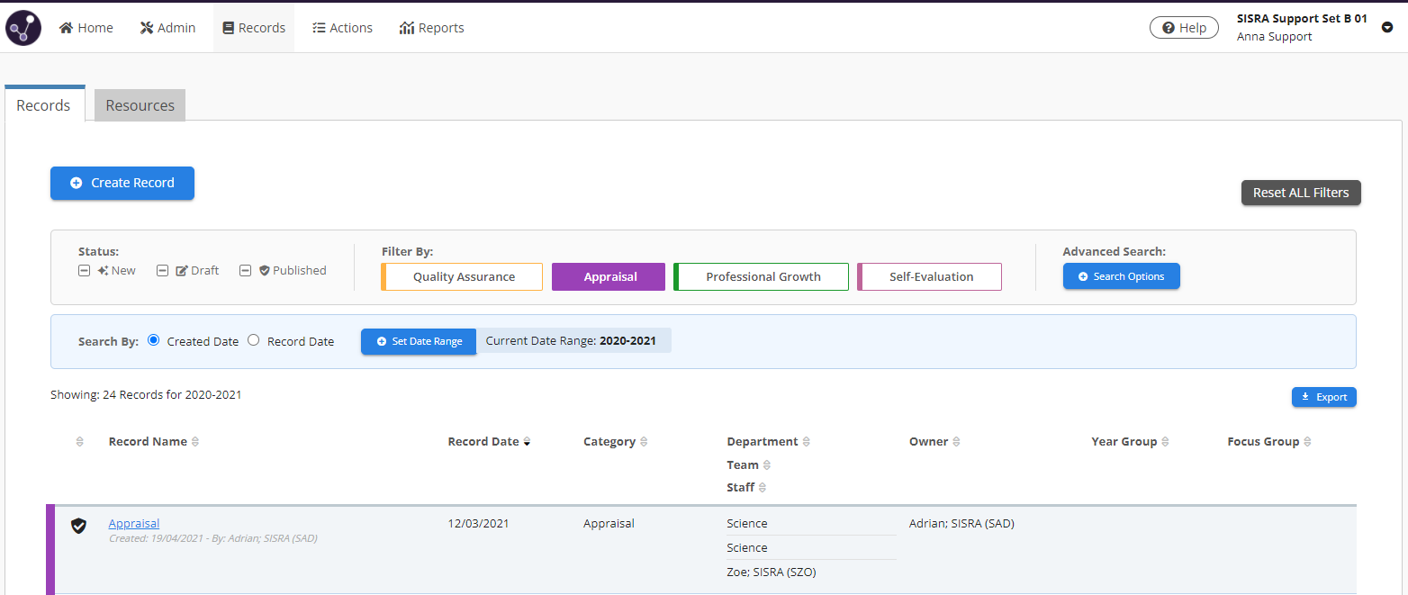

Click ‘Create Record’ and then select the type of record you want to create, i.e. Appraisal.

Appraisee is listed as ‘Staff’.

Appraiser is listed as ‘Owner’.

Filter by a specific template type, such as Appraisal.

Appraisal records which you can access are listed here. An appraiser will see multiple records but if you are only responsible for your own appraisal record then you should only see your own.
Click on a record name to access this.

Saving, Publishing & Modifying a Record
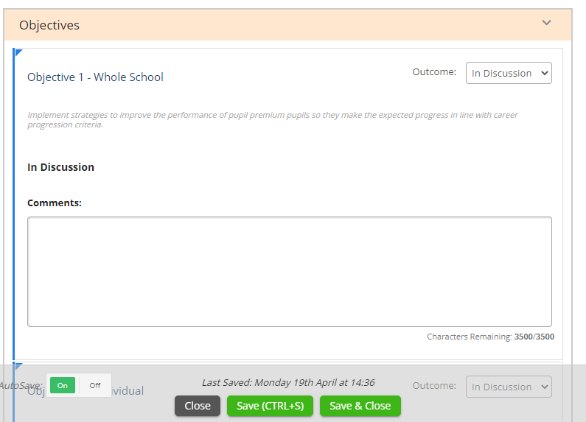
Appraisal records may need to be edited throughout the year at each review period. The process would work like this: Objectives Setting:
- Create record
- Start it to enter objectives & Save it
- Publish record

After clicking ‘Start’ or ‘Modify’, you can edit the content of a record.

First Review Period:
- Unpublish Record
- Modify Record & Save it
- Publish Record

Second Review Period:

‘Save & Close’ a record when finished. Observe will also AutoSave as you make changes, but you can also manually save by clicking ‘Save (Ctrl+S)’.

- Unpublish Record
- Modify Record & Save it
- Publish Record

… And so on until record is published for the final time.

Publish a record once you’re finished with it for that review period. You can then ‘Unpublish’ it to ‘Modify’ its content for the next review period.

