
Creating a Record Handout
You can create records from the Home area of Observe, by clicking the + icon next to the relevant template type in the Record Stats section. You can also create records by navigating to Records > then click Create Record and select the appropriate type of record from the options available.
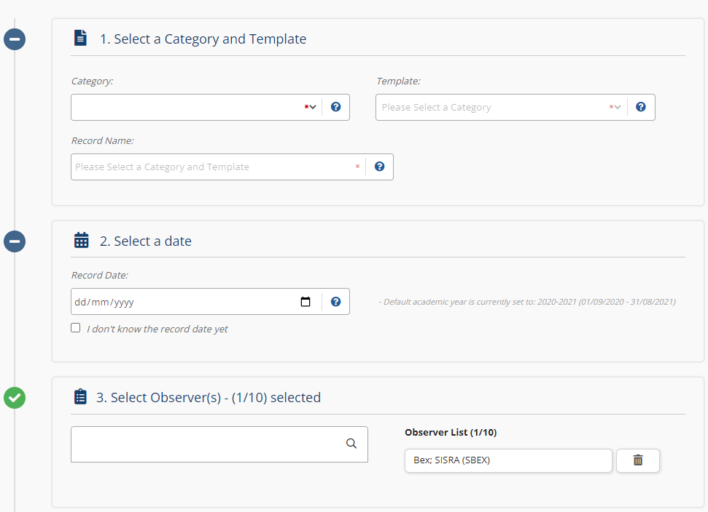

Click the icon to remove Observers/Owners if needed!

Click the tick box if you’re not sure of the record date yet, this can be altered when necessary.

This will tell you the current academic year in use.
While a date is not required to create a record, one must be entered to publish it.

1. | Select the category from the Category dropdown box.  Select the template from the Template dropdown box.  Tip - The record name will automatically be populated based on selections, but you can click in and edit this if needed.
2. | Click into the Record Date text box to select the date of the record.
3. | Click inside the Observer/Owner List box and search and select the appropriate Observer/Owner/s for the record. You can add up to 10! This would usually be the individual/s who will be responsible for completing the record and should have access to start, modify, publish and view this.  As the record creator, you will automatically be added as an Observer/Owner on the right .
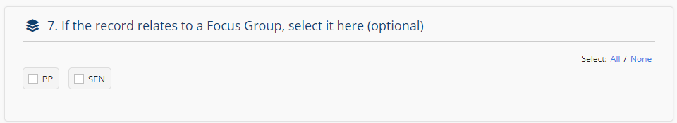
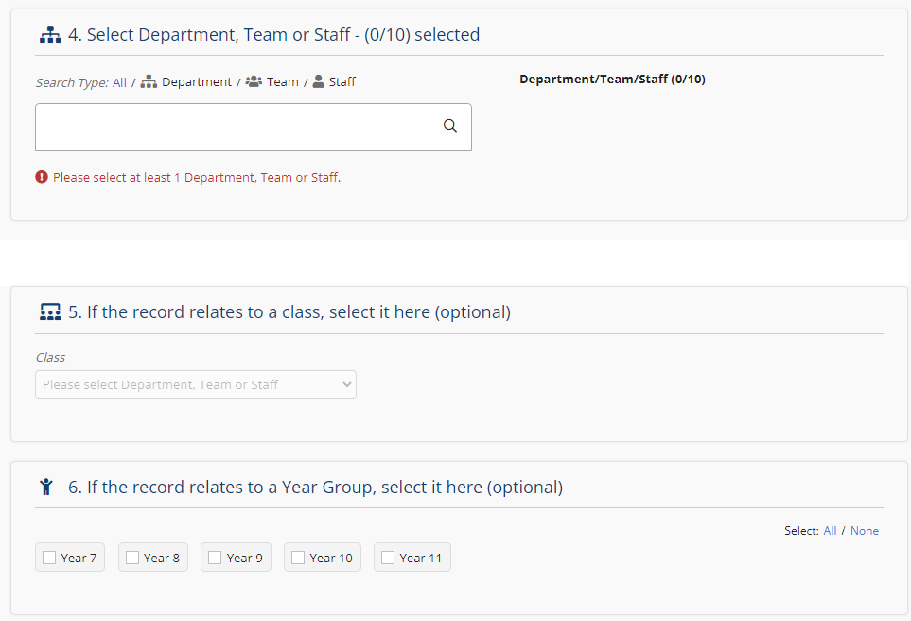
Thanks for reading!

Select any Year Groups / Course Levels and Focus Groups you want to link to the record to help you filter your data once created.

You have the option of selecting a class context here if available, which will add information about the class being observed to the record!

4. | Click inside the Department/Team/Staff box.  Select the department, team and/or staff member that is being observed. You can add up to 10 combinations of these on one record!
5. | Optional – Select if the record relates to a class  This allows you to see contextual information that has been imported about that class!
6. | Optional – Select the year group/s or course level/s the record relates to, if applicable.  This means you can filter and view performance by year group or course level in the reports!
7. | Optional – Select if the record relates to any focus groups.  This means you can filter and view performance by focus group in the reports!
8. | Click Create at the bottom of the page to confirm your choices, then click Start on the next page to begin completing your record.

